

**ASSIGNMENT FRONT SHEET**

**Course Name: ALY6050 20906 Intro to Enterprise Analytics**

**Professor Name:**  **Dr. Christopher Johnson**

**Student Name: Dong Quoc Tuong (Lukas)**

**Student Class: Fall 2019 CPS Term: B. 2020**

|  |
| --- |
| **Module 5:** **Simulation**  **Completion Date: 22th March Due Time:12:00am** |

**Statement of Authorship**

*I confirm that this work is my own. Additionally, I confirm that no part of this coursework, except where clearly quoted and referenced, has been copied from material belonging to any other person e.g. from a book, handout, another student. I am aware that it is a breach of Northeastern University’s regulations to copy the work of another without clear acknowledgement and that attempting to do so renders me liable to disciplinary procedures. To this effect, I have uploaded my work onto Turnitin and have ensured that I have made any relevant corrections to my work prior to submission.*

**Tick here** to confirm that your paper version is identical to the version submitted through Turnitin

**Executive Summary**

Practitioners in business process management make calculated decision to lead the organizations and people from old method to new ways of doing business. And simulation is the sure way to accelerate changes. Thus, they see stimulation as a necessary test in order to anticipate possible outcomes accordingly. Researchers will often analyze the nature of the companies, strategies and other elements before recommending the appropriate simulation system. This paper provides a definition of the business simulation and a frame work to develop one. Furthermore, we will also have a look at example of simulation model and the application of the model to the Fashion industry’s assembly line production.

**Background and Literature**.

Business Simulation, in its simplest form, is the fame learning methods for representations of a company in the macro and micro economic environments. Thanks to its multi learning benefits, business simulation is used for the training of management and leadership skills. This includes the strategies formulation, results-altering factors analysis, as well as analytical skills and team communication’s improvement. There are two types of business simulations:

* Cases studies that are illustrated through Excell for practices
* Simulations that are resulted from a more or less difficult beginning state embedded into the company’s vein by the executive’s decision.

As up this moment, there is no evidence suggesting that one way of simulation learning outperforms the other. Most researchers suggest that a combination of both models is best to address the problem (Schröder ,P. & Liuvu,C., 2012). There are three steps in the development of the Simulation model

1. **Development- setup**: One of the most significant factors simulation developers struggle with is reaching a balance between cost and design. There is a positive correlation between reality reflection and cost, the more likely a crisis can happen, the more it cost. Factors such as complexity of the rules, goals variations, graphics and visual attractiveness, etc. are some of the factors to enhance trainees’ engagement. In addition, developers need to have the relevant and correct content to found the base of the simulation. Content must be aligned to the users’ interests. Then they need to test the simulation
2. **Design- adjustability:** Now we will optimize the learning environment to accommodate the levels of users’ ability. If the simulation is too hard, users will be frustrated, if it is too easy, they will get bored. Optimal engagement is earned when users enter the “Flow” state, challenging but doable tasks.
3. **Design –Engagement:** Users have two attributes: “virtual optimism” and “blissful productivity”. “Virtual optimism” means users to the users’ immediate impulse with reasonable hope of success while “blissful productivity” means the users feel whole when they are hard-working. Designers can include Rewards and feedbacks from the superiors to be motivated. (Batko, 2016)

**Analysis**



We will use the Performance Lawn Equipment Model to know how many second shifts will be needed in the budget of the following year. We use the Randbetween() function between 2 values 80 and 130 to find the demand since it is the range of fluctuations. By adding production to the beginning inventory and subtracting the demand, we have the ending inventory. The second shift is only needed (1) when the Ending inventory is less than 50, otherwise it would be 0. The total ending of the inventory post second shift production equals to the combination of the ending inventory and the second shift production.



When we finnally compute the total second shift, we will run the probability distribution for only the first shift and then second shiftover 1 year (260 days). It is noted that the probability of the second shift is less than 0.05 (0.03), which means that the chance of having the second shift is so low that the business manager do not need to care.

 

However, this is just one scenario that the probability of the second shift is less than 5%, what about another year. Therefore, the Monte Carlo Simulations: were introduced into our analysis. By running the analysis by 1000 trials we have the figures above. On average, the probability of the second shift is about 5.02%, standard deviation is 0.94%. And we see that the probability of the second shift that is higher than 5% has approximately 50% chances to occur but there is only 1 % of chances that the probability is more than 7%. It is too low. To sum up, the business leaders can dismiss ignore the overall chances that the customer needs a second shift of production

**Application**

We are examining Stimulation this week for Assembly line production of clothing from the article:  “Clothing assembly line design using simulation and heuristic line balancing techniques”.  (Eryuruk,S, 2012) The demand for greater product types and shorter life cycled fueled the existence of assembly lines in the textile industry. There are three ways of production Assembly lines can organize, but clothing manufacturing only uses two: multimodel and mixed model. Different products or different models of the same type of product are assembled on multi-model assembly line by the end. This begs the question of how we can optimistically balance the productivity among work stations to ensure the best result. Researchers use two heuristics methods to address this issue

* 1. Probabilistic line balancing technique: employs the normal probability distribution and standard deviation values of standard times to balance assembly lines.
  2. Largest Set Rule Algorithm: assigning a set of related operations to a worker rather than the operation-by-operation allotment, thereby allowing much more freedom and flexibility in sequencing the workers. Therefore, this is the more preferred method.

Most assembly lines are created base on the companies’ past experiences. This study uses the dress assembly line for the first stage of the Arena simulation program. In the first part, the researcher introduced a theoretical methodology to identify essential objectives constraints, metics and functions. Then they use d the simulation of the current assembly line to observe the time losses and queues. Researchers saw a decrease of 5 workstations from 34 to only 29 when applying “Probabilistic line balancing techniques” method for this assembly line. It is noted that this method provides more reliable results in exchange for lower line efficiencies and a higher number of workstations. On the other hand, the Largest Set Rule Algorithm less reliable result but high line efficiencies and lower number of workstations (29 to only 25). In the end, researchers decided to go with the first approach rather than the second but stated that it is up to the model requirements and the company’s goals

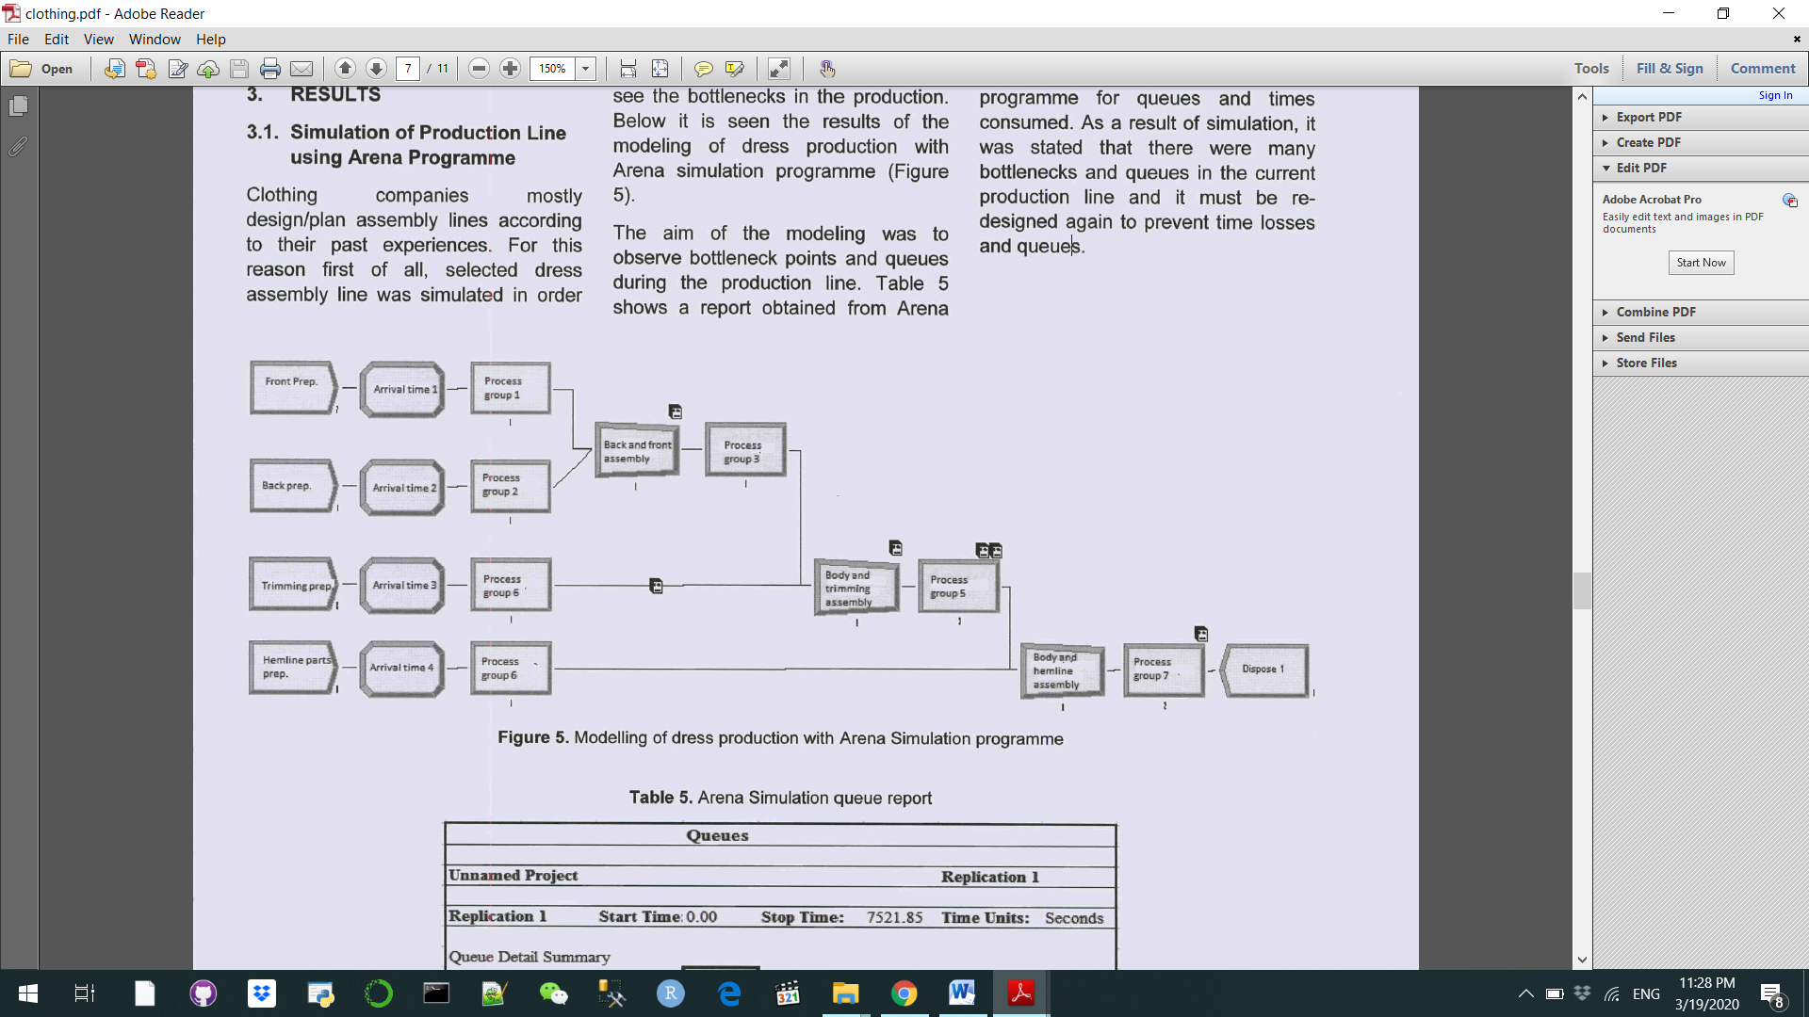

**References**

Batko, M. (2016). Business Management Simulations – a detailed industry analysis as well as recommendations for the future. *International Journal of Serious Games*, *3*(2). <https://doi.org/10.17083/ijsg.v3i2.99>

Eryuruk, Selin. (2012). Clothing assembly line design using simulation and heuristic line balancing techniques. Tekstil ve Konfeksiyon. 22. 360-368.

Schröder, Hans Peter & Ciucan-Rusu, Liviu. (2012). Business Simulation.